Hi,   
I have work on user-story 2219.   
I had read all the ‘Payment Spring’ documentation and today I also implement all the APICall inside that documentation. Most of the APICall completed successfully, but I face issue in some APICalls, I googled for them but didn’t find any solution so I thought to consult with you.

I understand the flow Like create the customer, tokenization, add payment method, and assign to customer, do transactions refund, create receipt and its template like these all.

Issue are below

1-I am unable to retrieve ‘list of transactions’ ‘list of customers’ or list of anything

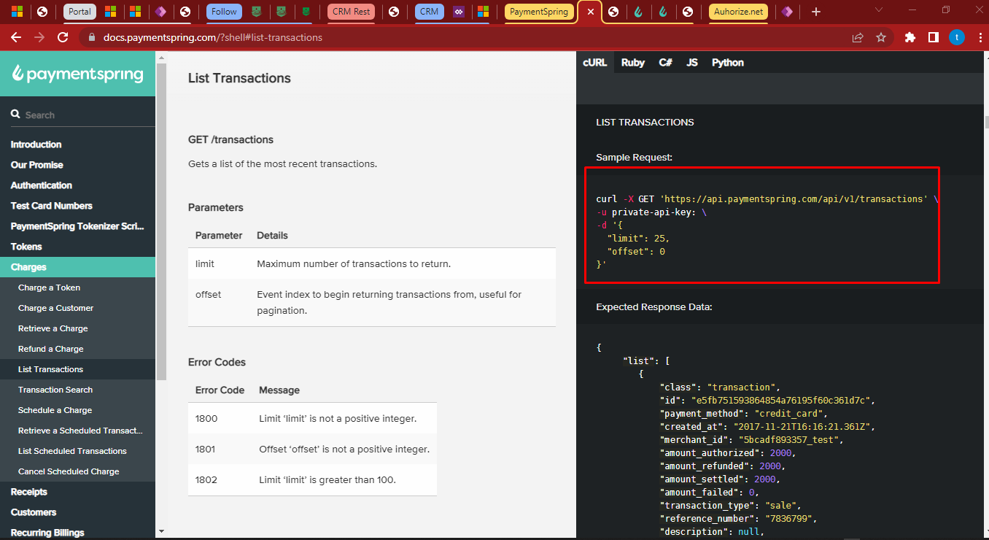

Postman generates error while I do this request.

2- I am also facing issue in below three requests

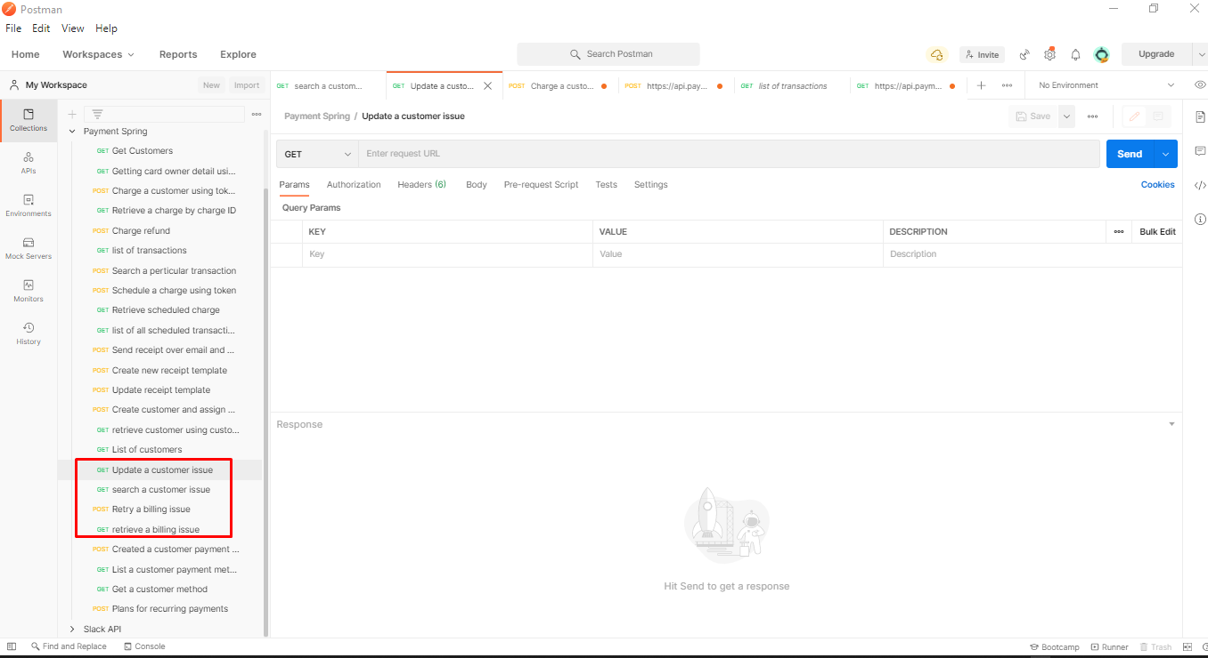

It says 403- forbidden error. I googled but didn’t find any solution regarding this payment spring method.

I have other questions regarding checkout page.

1. In replica website, I noticed if we have only one record in cart that is regarding ‘Give monthly’, then a section appears to make that payment as recurring payment. (For recurring payment, we have concept in payment spring as PLANS, and we can subscribe that plans to a customer).   
   Do we need to achieve this into our website?   
   if yes, in recurring payments, we have frequency like daily monthly, how we need to fill this frequency? Do we need to use ‘Monthly bi-annually and other checkbox to fill that frequency?’
2. I have question regarding checkout page record save. Like how we need to proceed of record saving when click on ‘payment proceed’ button inside checkout page.

Like, as per ‘payment spring’ documentation what I understand,

1. first, we will get the login user into PowerApps portals, and create a customer with that named into ‘payment spring’.
2. Then we will get the user entered ‘account detail’ and add that account detail into ‘payment spring’ as well assign that account detail to newly created customer. After that we can store the transactions in ‘payment spring’ regarding customer. And rest of data we can save into ‘CRM transaction entity’, but we do not have fields into CRM. Am I right? Please write your reviews regarding this.